A Total Eclipse of the Sun
Monday, April 8, 2024
This information sheet is intended for the general public,
prepared by the Belleville Centre of the Royal Astronomical Society of Canada

On April 8, 2024, a total eclipse of the sun will cross southern Ontario for the first time in 400 years, and the last time in 375 years. In such a total eclipse, the Moon exactly covers the Sun, and our star’s faint atmosphere (the corona) becomes visible. Everyone else in North and Central America will see a partial eclipse of the Sun, with a bigger “bite” taken out of the Sun the closer you are to the path of the total eclipse.
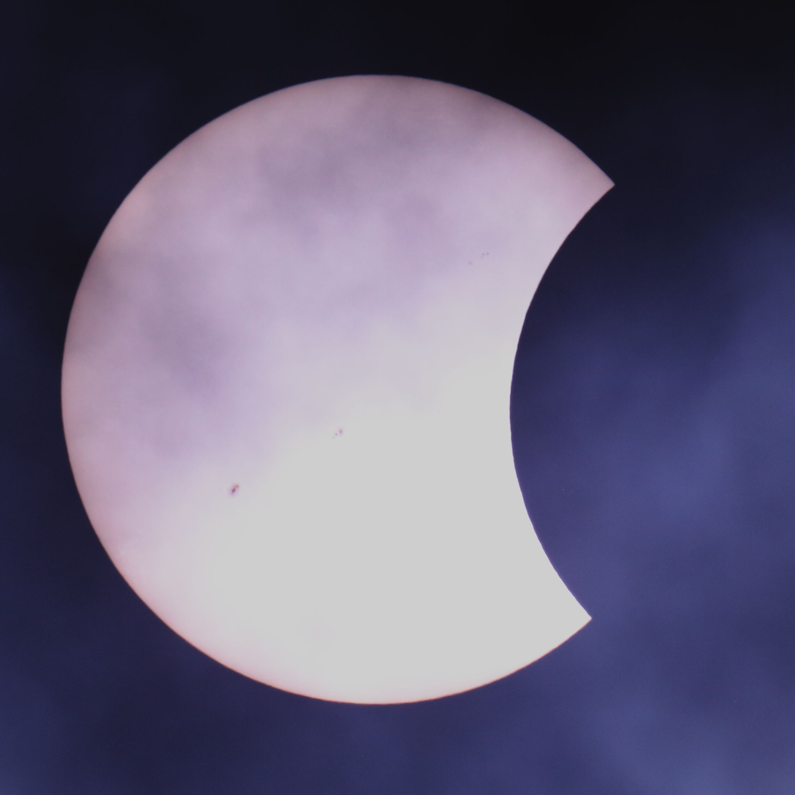
Most people in North America will see a partial eclipse.
Photo by Donald Town, Belleville RASC

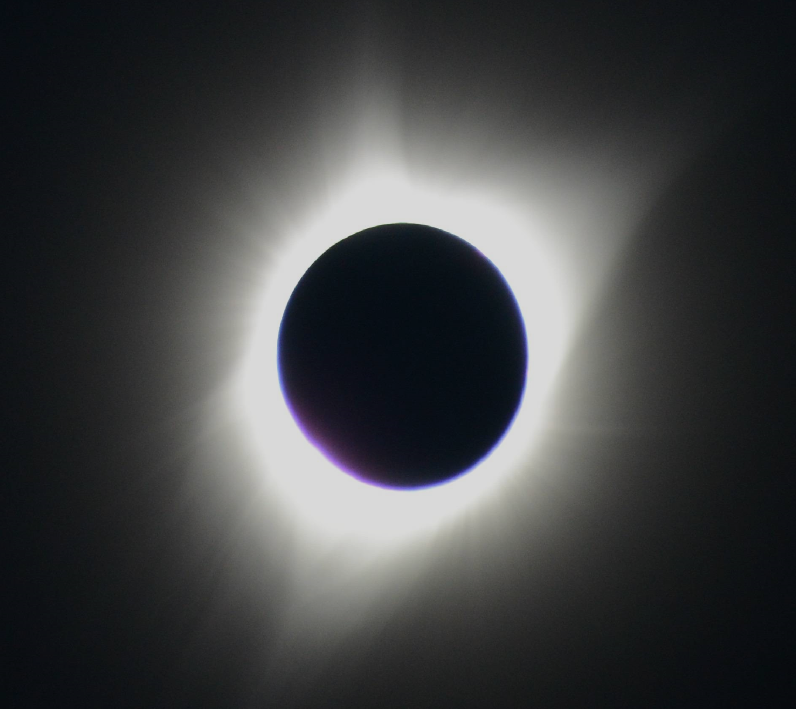
Only those people in the narrow path of totality will see the total eclipse.
Photo by Randy Boddam, Belleville RASC
If you are on the path, when only a sliver of sunlight remains visible, your surroundings will begin to darken, as if the Sun were setting in the middle of the day. Temperatures will drop and birds will go to roost, thinking that night is coming. Finally, the Sun will be totally covered and the beautiful solar atmosphere (the corona) will become visible. Totality will last four minutes or less and then the Sun will slowly be uncovered.
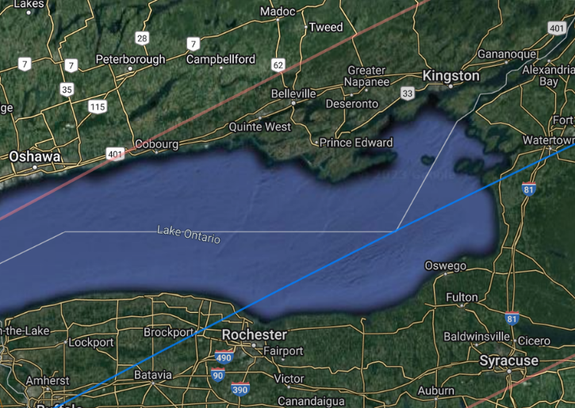
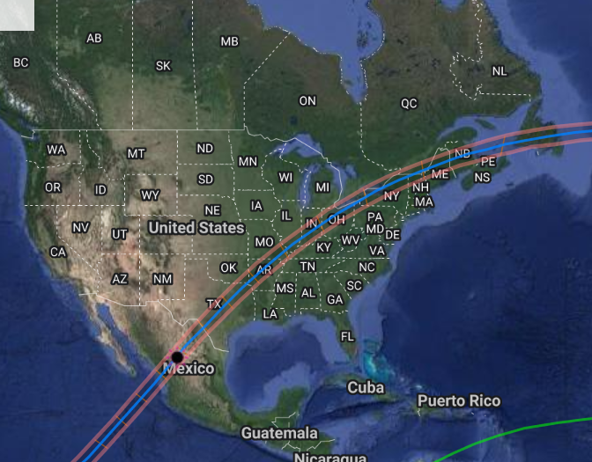
The path of the total eclipse.
Credit: Xavier Jubier

A Total Eclipse of the Sun | Monday April 8. 2024

Location | Partial Begins | Total Begins | Eclipse Maximum | Total Ends | Partial Ends
Presqu’ile Park - Lighthouse | 2:07:41 p.m. | 3:21:03 p.m. | 3:22:14 p.m. | 3:23:25 p.m. | 4:33:21 p.m.
Brighton - Downtown | 2:07:39 p.m. | 3:21:10 p.m. | 3:22:11 p.m. | 3:23:11 p.m. | 4:33:18 p.m.
Quinte West - City Hall | 2:07:55 p.m. | 3:21:24 p.m. | 3:22:24 p.m. | 3:23:24 p.m. | 4:33:27 p.m.
Belleville Library | 2:08:15 p.m. | 3:21:39 p.m. | 3:22:40 p.m. | 3:23:40 p.m. | 4:33:38 p.m.
Sandbanks Provincial Park | 2:08:13 p.m. | 3:21:08 p.m. | 3:22:45 p.m. | 3:24:21 p.m. | 4:33:47 p.m.
Picton - Downtown | 2:08:27 p.m. | 3:21:23 p.m. | 3:22:54 p.m. | 3:24:25 p.m. | 4:33:52 p.m.
Deseronto - Downtown | 2:08:44 p.m. | 3:21:50 p.m. | 3:23:05 p.m. | 3:24:19 p.m. | 4:33:57 p.m.
Napanee - Downtown | 2:08:55 p.m. | 3:22:01 p.m. | 3:23:13 p.m. | 3:24:26 p.m. | 4:34:02 p.m.
Note: all times listed are hr:min:sec EDT (Eastern Daylight Time) and timing varies by location

When and Where
Observing the Sun Safely
Because some part of the Sun will be showing during most of this eclipse, it will be important to use safe viewing strategies to protect your eyes. It is never safe to look directly at the Sun, except during the brief period of totality, when you can only see the faint solar corona by looking directly at the eclipsed Sun.
Regular sunglasses, swimming goggles, and most camera filters are NOT safe for looking directly at the Sun. You can observe the Sun indirectly using the suggestions below. Or you can safely protect your eyes with certified solar-viewing glasses available from your local RASC Centre.
Make sure that on the back, in small print, they say that they are ISO 12312-2 certified.
At the top of this page is information for what will happen in our area. Hopefully, the skies will be clear and you can get a great view of this rare astronomical event. There will not be another total eclipse visible in Canada until 2043. You can find out what will happen at other locations by going to: www.timeanddate.com/eclipse/solar/2024-april-8
There are many indirect ways to observe the eclipse, so having solar-viewing glasses is not required. An easy method to observe the eclipse is to take a cardboard box, cut a viewing hole on one end and on the same end, make another hole, covered in aluminum foil with a pinhole in it (taking care to make a small, neat hole). Tape a white sheet of paper on the opposite end of the box to act as a viewing screen. Then, stand with your back to the Sun and let the Sun’s light fall through the hole and onto the sheet at the opposite end. You’ll get a small but distinct image of the Sun. The longer the cardboard box, the larger the image of the Sun will be.
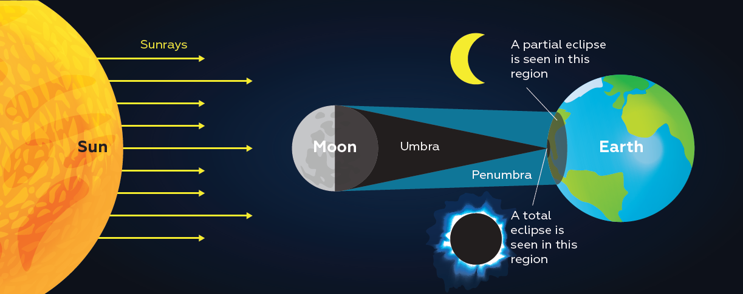

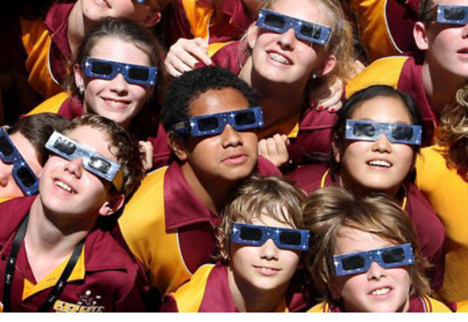

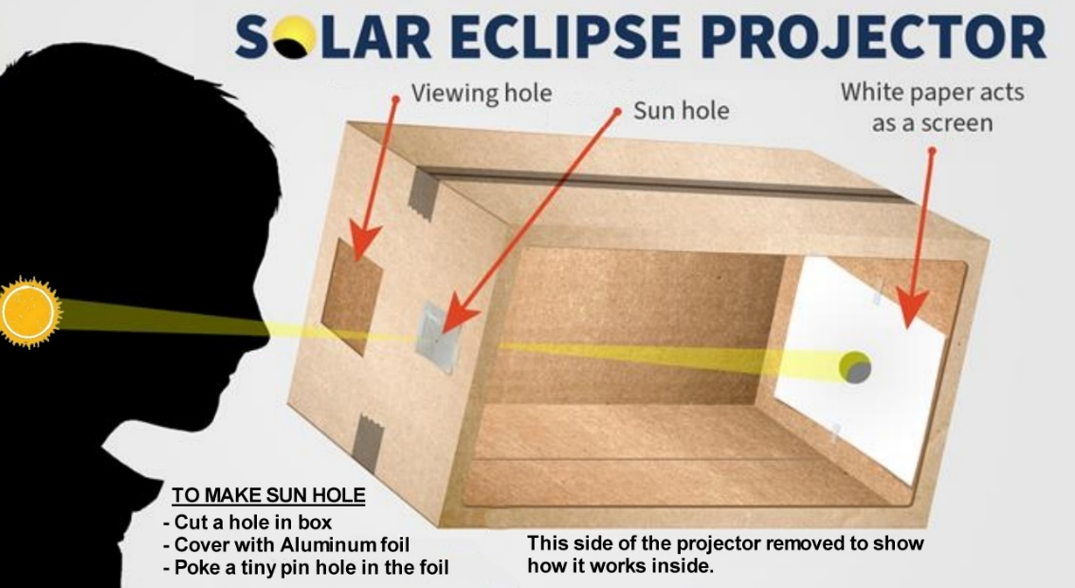

Additional resources can be found at:
www.rasc.ca or www.rascbelleville.ca

