78th year, is one of 25 Centres spread across Canada, from St.John’s to Victoria.

You are welcome to attend our monthly meeting, held on the third Friday of the month (except August) at Fanshawe College, 1460 Oxford St. E, London, Room B1027, from 7:00pm to 9:00pm.

Meetings include notice of upcoming astronomical events, members observing reports and a program of talks and presentations. You just never know who might turn up. Recently we were visited by astronomers David Levy and Thomas Bopp, co-discover of comet Hale-Bopp, and they shared their exciting stories with us.

A lively informal meeting always continues at a nearby restaurant, where you can really get to know other members and our guests.

On the Sunday following our meeting the Observers Group gets together at a member’s home to share ideas and discuss astronomical topics while relaxing and snacking.

When the skies clear, and the moon isn’t too bright, members may take their telescopes and binoculars to the Fingal Wildlife Management Area, about thirty minutes south-west of London, to enjoy dark skies away from London’s light pollution. The site offers off road parking, and plenty of flat grassy field to set up telescopes. You can receive a guided tour of the sky from one of our members using their telescope.
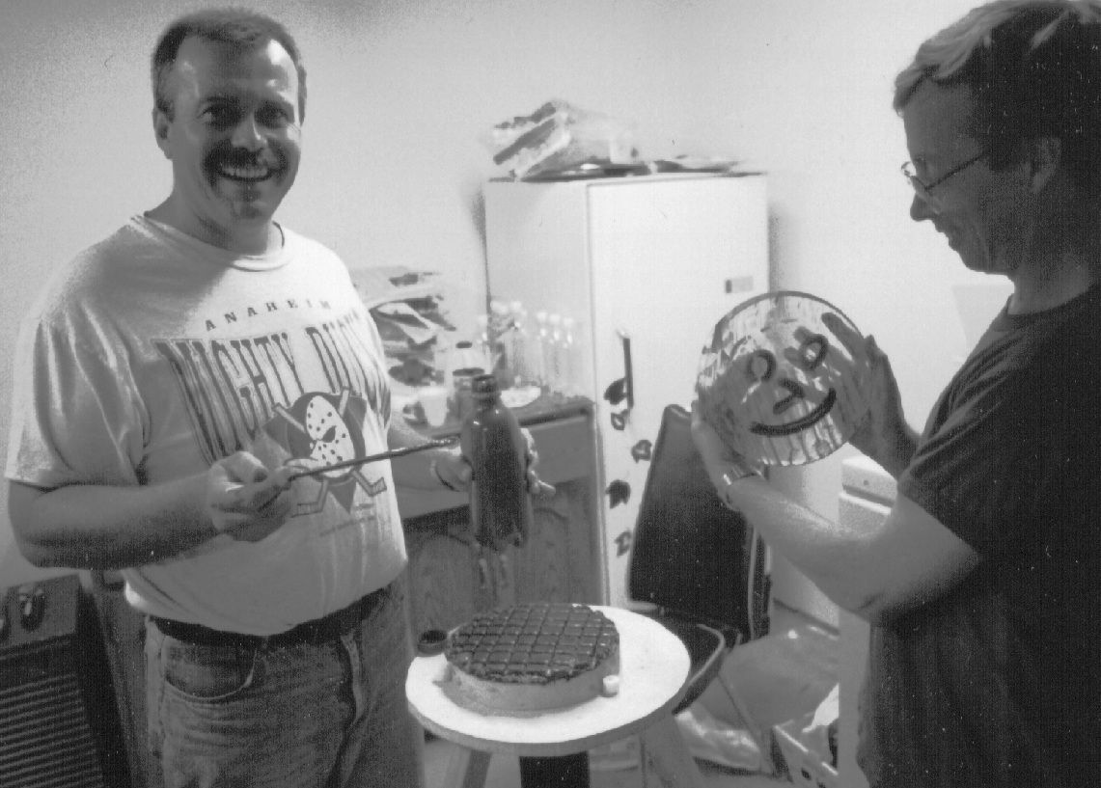

We have expertise in Astronomy. Observers who have spent years learning the night sky are always willing to share its’ secrets and help the novice find their way around. Our members know how to use the equipment of astronomy, have strong opinions on what works, and what doesn’t. After you have looked through a few members’ telescopes you will better know which way to go on your own purchase, or you may wish to work with our Amateur Telescope Makers who guide interested members in the grinding and polishing of glass to make their own telescope.

Experienced Astrophotographers in our Centre share their techniques to photograph the stars. Members are also building and using CCD cameras to capture astroimages directly into their computers.

Our most avid observers enjoy the night sky all year, while others concentrate their observing during the clear warm nights of summer. Every year over thirty London Centre members attend the premier Canadian star party “Starfest” held near Mount Forest with over nine hundred other enthusiasts. Centre groups also travel long distances to attend Stelefane in Vermont, The Texas Star Party, The Winter Star Party, solar eclipses, and other astronomical events. You can too!

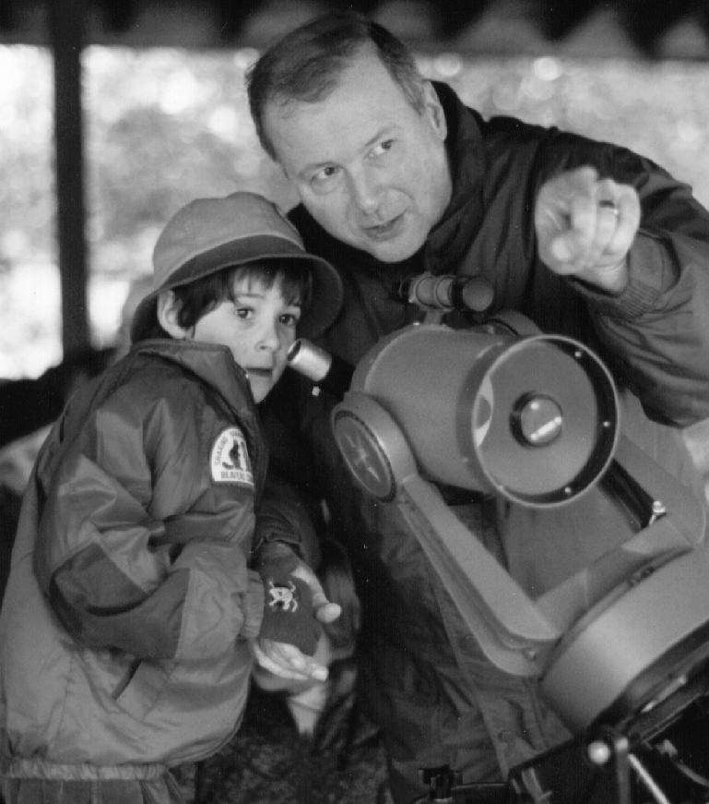

London Centre members share their love of astronomy with children, scouters, and the public through presentations, public star nights, high school presentations, and mall displays.

An interest in the oldest science might be just the spark to start a child into a career in science and technology.

Membership is open to all novice and experienced sky lovers. You do not need to own your own telescope to join.

Annual adult membership fees are $44.00, $25.00 for youth memberships. To join, contact our treasurer Shawn Osterberg at the meetings, or at 686-3986.

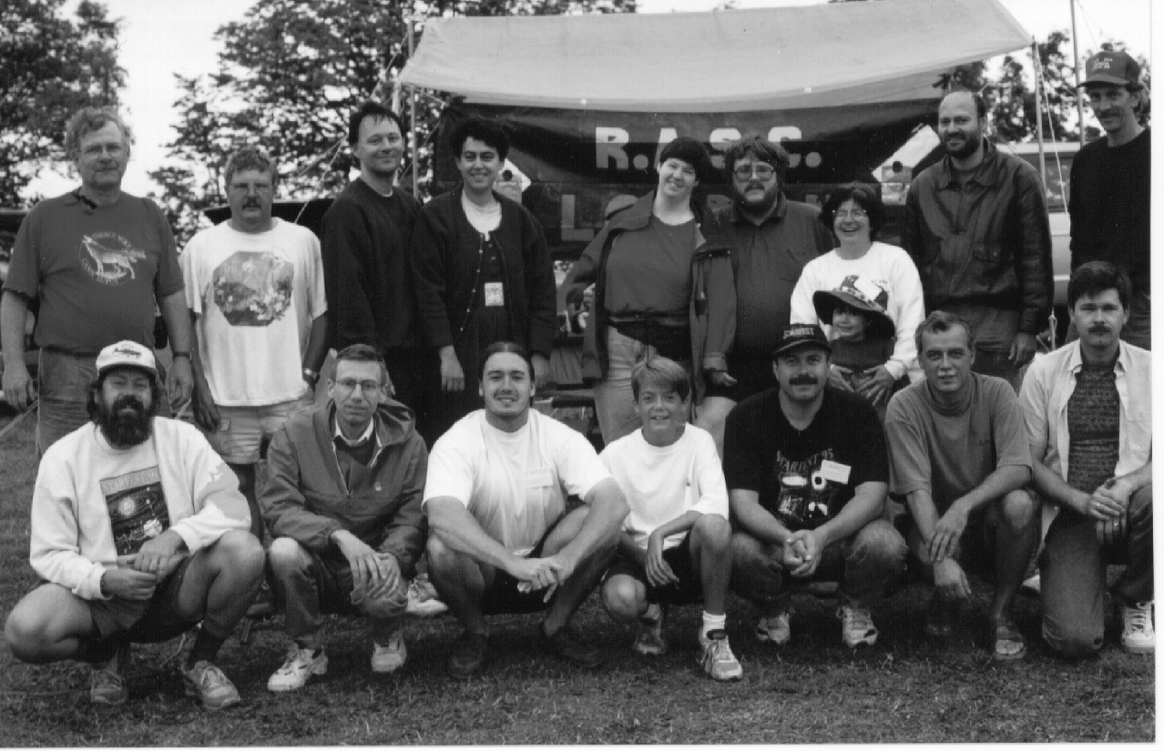

As a member you would receive:
- The RASC Observers Handbook which contains comprehensive information on the year’s astronomical events, articles on observing comets, meteors, planets, the moon, deep sky objects, and much more.
- The Journal is a bimonthly periodical mix of members’ articles, astronomy news from across Canada, and peer reviewed research articles.
- SkyNews is the popular bimonthly Canadian astronomy magazine edited by Terry Dickenson.
- Polaris is our critically acclaimed Centre Newsletter available at each meeting or by mail if you live out of town.
- The RASC Beginner’s Observing Guide may be purchased at a significant discount by new members.
- Borrowing privileges from our excellent library of astronomy books.
- Rental privileges to the Centre’s 6 and 8 inch Dobsonian telescopes, and after suitable training you may also use the Centre’s 16 inch f4.5 telescope.
- Your name and phone number can be added to the Observers Call Out list, to be notified when and where other members will be observing.
- The Astro-London Email List speeds communications with other center members about observing sessions and London Astronomy news.
- Membership in the Observers Group, Amateur Telescope Makers, the CCD Group, the Astrophotography Group, and enjoy all other Centre activities.

Internet: Visit the Centre Web Page at: http://phobos.astro.uwo.ca/%7erasc/

Mailing Address:
P.O. Box 842
Station B,
London, Ontario,
Canada
N6A 4Z3

The Royal Astronomical Society of Canada

London Centre

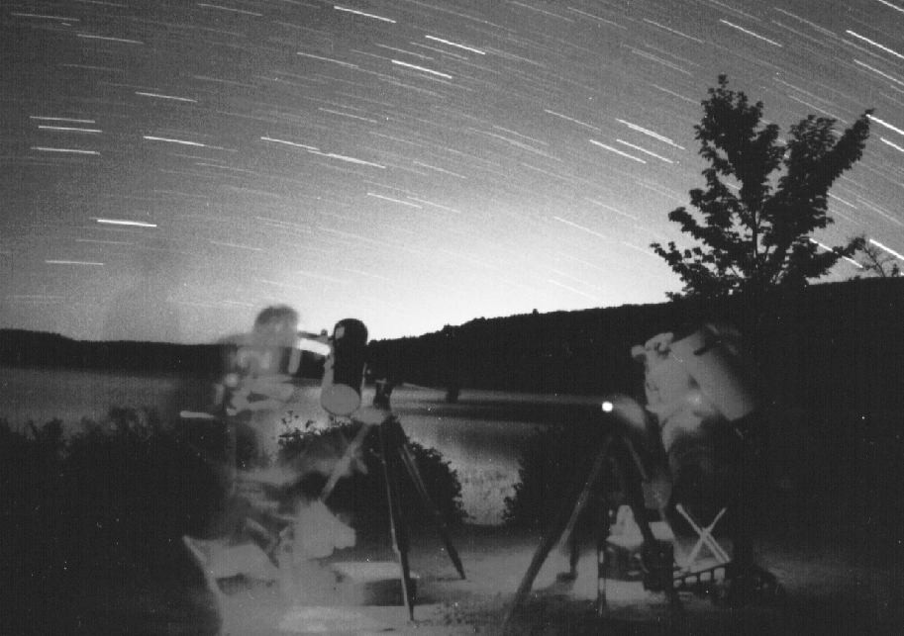

Amateur Astronomy is great fun, deeply satisfying, filled always with wonder and awe, and sometimes tremendous excitement. It is also a sedate, peaceful, and affordable hobby, both technical and ethereal, that brings people together and creates experiences and memories for a lifetime.

The Royal Astronomical Society of Canada is made up of persons of all ages and from all walks of life who share a keen interest in Astronomy. The London Centre, now in its

